UNIVERSITY OF JAMMU

Website: jammuuniversity.ac.in


Practical File
on
P2CSPC280: Practical
(Session: 2025-26)

Submitted By
Danishwer
MCA -2nd Sem
Roll no: 0026MCA25

CERTIFICATE

This is certified to be the Bonafide practical work in C++/HTML/JS in Second Semester of MCA programme during the academic year 2025-26.
This file is prepared by Danishwer , roll no. 0026MCA25, Department of Computer Science and IT.

Teachers-In-Charge:-
- Prof. Vinod Sharma
- Dr. Shubhnandan Singh Jamwal
- Dr. Namrata Karlupia
- Dr. Rajneet Kour

Internal Examiner External Examiner

INDEX

DSA

- Write a program to insert an element at a given position in an array.
- Write a program to delete an element from a given position in an array.
- Write a program to search for an element using linear search.
- Write a program to search for an element using binary search.
- Write a program to reverse an array (in-place).
- Write a program to merge two arrays.
- Write a program to remove duplicate elements from an array.
- Write a program to implement matrix multiplication.
- Write a program to create a singly linked list and count the number of nodes.
- Write a program to insert a node at the beginning, end, and a specific position of a singly linked list.
- Write a program to reverse a singly linked list.
- Write a program to merge two singly linked lists.
- Write a program to implement binary tree traversal (Preorder).

Web Technology:
- Write a program to enter the marks of students in 4 subjects and find out the sum and average of the marks obtained
- Write a program to enter a three digit number and find out the sum of all the digits
- Write a program to enter the number and find if the number is prime or not
- Write a program to print all the Armstrong numbers from 100 to 500
- Write a program to print first 20 prime numbers
- Write a JavaScript program to demonstrate all the events of the Keyboard and Mouse
- Write a ReactJS Component to find the largest among three numbers
- Write a NodeJS Code to create a server and send the Rno, Name and Marks in 4 subjects from the client form to the server and return the sum of the marks obtained

Data Structures using C++

1. Write a program to insert an element at a given position in an array.

#include <iostream>
using namespace std;

void insert(int item, int index, int *array, int size)
{
int i = size - 2;
// Right shifting
while (i >= index)
{
array[i + 1] = array[i];
i--;
}
array[index] = item;
}
int main()
{
int array[] = {1, 2, 3, 4, 5};
insert(2, 3, array, 5);
for (int i : array)
{
cout << i << " , ";
}
return 0;
}

OUTPUT :
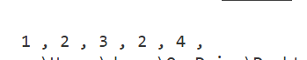

2. Write a program to delete an element from a given position in an array.

#include <iostream>
using namespace std;
void remove(int index, int *array, int size)
{
// Left Shifting
for (int i = index; i < size; i++)
{
array[i] = array[i + 1];
}
array[size - 1] = 0;
}

int main()
{
int array[] = {1, 2, 3, 4, 5, 6, 7};
remove(3, array, 7);
for (int i : array)
{
cout << i << " , ";
}

return 0;
}

OUTPUT :

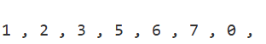

3. Write a program to search for an element using linear search.

#include <iostream>
using namespace std;
int search(int item, int *array, int size)
{
// Left Shifting
for (int i = 0; i < size; i++)
{
if (array[i] == item)
return i;
}
return -1;
}

int main()
{
int array[] = {1, 2, 3, 4, 5, 6, 7};
cout << "Found 7 at : " << search(7, array, 7) << "\n";
cout << "Found 8 at : " << search(8, array, 7);
return 0;
}

OUTPUT :

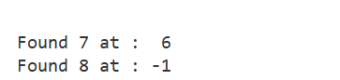

4. Write a program to search for an element using binary search.
#include <iostream>
using namespace std;
int search(int item, int low, int high, int *array, int size)
{
while (low <= high)
{
int mid = high - (high - low) / 2; // to avoid overflow
int current = array[mid];
if (item < current)
return search(item, low, mid - 1, array, size);
else if (item > current)
return search(item, mid + 1, high, array, size);
else
return mid;
}
return -1;
}
int main()
{
int array[] = {1, 2, 3, 4, 5, 6, 7};
cout << "Found 2 at : " << search(2, 0, 6, array, 7) << "\n";
cout << "Found 6 at : " << search(6, 0, 6, array, 7) << "\n";
cout << "Found 8 at : " << search(8, 0, 6, array, 7);
return 0;
}

OUTPUT :
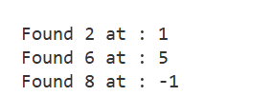

5. Write a program to reverse an array (in-place).
#include <iostream>
using namespace std;
void reverse(int *array, int size)
{
int low = 0;
int high = size - 1;
while (low <= high)
{
swap(array[low], array[high]);
low++;
high--;
}
}
int main()
{
int array[] = {1, 2, 3, 4, 5, 6, 7};
reverse(array, 7);
for (int i : array)
{
cout << i << " , ";
}
return 0;
}

OUTPUT :
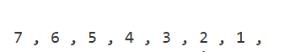

6. Write a program to merge two arrays.
#include <iostream>
using namespace std;
int *merge(int *array1, int size1, int *array2, int size2)
{
int total_size = size1 + size2;
int *result = new int[total_size];
int i = 0;
for (; i < size1; i++)
{
result[i] = array1[i];
}
for (; i < total_size; i++)
{
result[i] = array2[i - size1];
}
return result;
}
int main()
{
int array1[] = {1, 2, 3, 4, 5, 6, 7};
int array2[] = {1, 22, 13, 4};
int *array3 = merge(array1, 7, array2, 4);
for (int i = 0; i < 11; i++)
{
cout << i[array3] << " , ";
}
return 0;
}

OUTPUT :

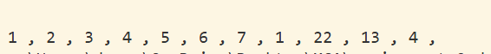

7. Write a program to remove duplicate elements from an array.
#include <iostream>
using namespace std;
void remove_duplicate(int *array, int size)
{
int *result = new int[size];
int k = 0;
for (int i = 0; i < size; i++)
{ bool found = false; int current = array[i];
for (int j = k; j >= 0; j--)
{if (current == result[j])
{found = true; break ;}
}
if (!found) {result[k] = current; k++;}
for (int i = 0; i < k; i++)
{
cout << result[i] << " , ";
}
}
int main()
{
int array[] = {1, 2, 1, 4, 4, 6, 7, 1, 0, 7, 9, 6};
for (int i : array)
{
cout << i << " , ";
}
cout << endl;
remove_duplicate(array, 12);
return 0;
}

OUTPUT :
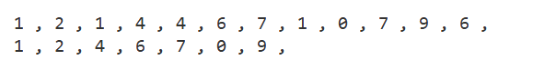

8. Write a program to implement matrix multiplication.
#include <iostream>
using namespace std;
void matix_multiplication(int m1[][4], int m2[][2], int r1, int c1, int r2, int c2)
{
if (c1 != r2)
{
cout << "row in m1 must be equal to col in m2";
return;
}
int **result = new int *[r1];
for (int i = 0; i < r1; i++)
{
result[i] = new int[c2];
}
for (int i = 0; i < r1; i++)
{
for (int j = 0; j < c2; j++)
{
int sum = 0;
for (int k = 0; k < c1; k++)
{
sum += m1[i][k] * m2[k][j];
}
result[i][j] = sum;
}
}
int r = r1;
int c = c2;
cout << "\n";
for (int i = 0; i < r; i++)
{
for (int j = 0; j < c; j++)
{
cout << result[i][j] << ",";
}
cout << "\n";
}
cout << "\n";
}
int main()
{
int m1[2][4] = {{1, 2, 3, 4}, {5, 6, 7, 8}};
int m2[4][2] = {{1, 2}, {3, 4}, {5, 6}, {7, 8}};
for (int i = 0; i < 2; i++)
{
for (int j = 0; j < 4; j++)
{cout << m1[i][j] << ",";
}cout << "\n";
}
cout << "\n";
for (int i = 0; i < 4; i++)
{
for (int j = 0; j < 2; j++)
{cout << m2[i][j] << ",";
}cout << "\n";
}
matix_multiplication(m1, m2, 2, 4, 4, 2);
return 0;
}

OUTPUT :
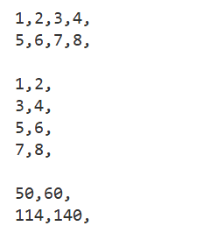

9. Write a program to create a singly linked list and count the number of nodes.
#include <iostream>
using namespace std;

struct Node
{
int data;
Node *node;
};

int count(Node *head)
{
int number_of_nodes = 0;
while (head)
{
head = head->node;
number_of_nodes++;
}
return number_of_nodes;
}
int main()
{
Node *n3 = new Node{3, NULL};
Node *n2 = new Node{3, n3};
Node *n1 = new Node{3, n2};

cout << "size : " << count(n1);
return 0;
}

OUTPUT :
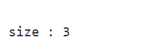

10. Write a program to insert a node at the beginning, end, and a specific position of a singly linked list.
#include <iostream>
using namespace std;
struct Node
{
int data;
Node *next;
};
Node *head;
void print()
{
Node *temp = head;
while (temp)
{
cout << temp->data << " -->";
temp = temp->next;
}
}
void insert_beginning(int value)
{
Node *new_node = new Node{value, NULL};
new_node->next = head;
head = new_node;
}
void insert_end(int value)
{
Node *new_node = new Node{value, NULL};
if (!head)
{
head = new_node;
return;
}
Node *temp = head;
while (temp->next)
{
temp = temp->next;
}
temp->next = new_node;
}
void insert_location(int value, int index)
{
if (!head || index == 0)
{
insert_beginning(value);
return;
}

Node *new_node = new Node{value, NULL};
Node *temp = head;
for (int i = 0; i < index - 1 && temp->next; i++)
{
temp = temp->next;
}
new_node->next = temp->next;
temp->next = new_node;
}
int main()
{
insert_beginning(2);
insert_beginning(1);
insert_end(3);
insert_end(4);
insert_location(-1, 0);
insert_location(5, 2);
print();
return 0;
}

OUTPUT :
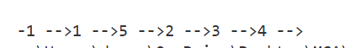

11. Write a program to reverse a singly linked list.

#include <iostream>
using namespace std;
struct Node
{
int data;
Node *next;
};
Node *head;

void print()
{
Node *temp = head;
while (temp)
{
cout << temp->data << " -->";
temp = temp->next;
}
cout << "\n";
}

void reverse()
{
Node *prev = NULL, *next = NULL, *cur = head;
while (cur)
{
next = cur->next;
cur->next = prev;
prev = cur;
cur = next;
}
head = prev;
}

int main()
{

Node *n3 = new Node{3, NULL};
Node *n2 = new Node{2, n3};
head = new Node{1, n2};
print();
reverse();
print();
return 0;
}

OUTPUT :
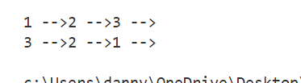

12. Write a program to merge two singly linked lists.
#include <iostream>
using namespace std;
#define N(x, y) \
new Node { x, y }
struct Node
{
int data;
Node *next;
};

void print(Node *head)
{
Node *temp = head;
while (temp)
{
cout << temp->data << " -->";
temp = temp->next;
}
cout << "\n";
}
Node *merge(Node *l1, Node *l2)
{
if (!l1)
return l2;
Node *temp = l1;
while (temp->next)
{
temp = temp->next;
}
temp->next = l2;
return l1;
}

int main()
{
Node *l1, *l2;
l1 = N(1, N(2, N(3, NULL)));
l2 = N(4, N(5, N(6, NULL)));
print(l1);
print(l2);
merge(l1, l2);
print(l1);
return 0;
}

OUTPUT :

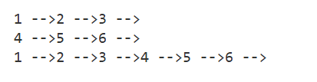

13. Write a program to implement binary tree traversal (Preorder).
#include <iostream>
#include <stack>
using namespace std;
struct Node
{
int data;
Node *left = NULL, *right = NULL;
};
void printNode(Node *node, int indentation)
{
if (!node)
return;

string indent(indentation, ' ');
cout << indent << "->" << node->data << "\n";

printNode(node->left, indentation + 2);
printNode(node->right, indentation + 2);
}
void printTree(Node *root)
{
cout << "Tree\n";
printNode(root, 0);
}

void print(Node *node)
{
cout << "[" << node->data << "]";
}
void preOrder(Node *root)
{
if (root == NULL)
return;
stack<Node *> s;
Node *cur = root;

while (cur)
{
print(cur);
if (cur->right)
s.push(cur->right);
if (cur->left)
cur = cur->left;
else
{
cur = s.top();
s.pop();
}
}
}

int main()
{
Node *n5 = new Node{5};
Node *n4 = new Node{4};
Node *n3 = new Node{3};
Node *n2 = new Node{2};
Node *n1 = new Node{1};
Node *root = new Node{0};

root->left = n1;
root->right = n2;
n1->left = n3;
n1->right = n4;
n2->left = n5;

printTree(root);
cout << "Preorder Traversal : ";
preOrder(root);
return 0;
}

OUTPUT :

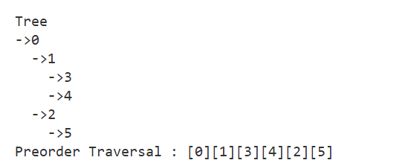

Web Technology

Index
S.No | Practical Name
1 | Write a program to enter the marks of students in 4 subjects and find out the sum and average of the marks obtained
2 | Write a program to enter a three digit number and find out the sum of all the digits
3 | Write a program to enter the number and find if the number is prime or not
4 | Write a program to print all the Armstrong numbers from 100 to 500
5 | Write a program to print first 20 prime numbers
6 | Write a JavaScript program to demonstrate all the events of the Keyboard and Mouse
7 | Write a ReactJS Component to find the largest among three numbers
8 | Write a NodeJS Code to create a server and send the Rno, Name and Marks in 4 subjects from the client form to the server and return the sum of the marks obtained

Practical 1 : Write a program to enter the marks of students in 4 subjects and find out the sum and average of the marks obtained
Source Code:
<html>
<head>
<title>Practical 1 - Sum & Average of Marks</title>
</head>
<body>
<h2>Sum & Average of Marks</h2>
<input id="s1" type="number" placeholder="Subject 1"><br><br>
<input id="s2" type="number" placeholder="Subject 2"><br><br>
<input id="s3" type="number" placeholder="Subject 3"><br><br>
<input id="s4" type="number" placeholder="Subject 4"><br><br>
<button onclick="calc()">Calculate</button>
<p id="res"></p>
<script>
function calc() {
var a = +document.getElementById('s1').value, b = +document.getElementById('s2').value, c = +document.getElementById('s3').value, d = +document.getElementById('s4').value;
var sum = a + b + c + d;
document.getElementById('res').innerHTML = "Sum: " + sum + "<br>Average: " + (sum / 4);
}
</script>
</body>
</html>
Output:
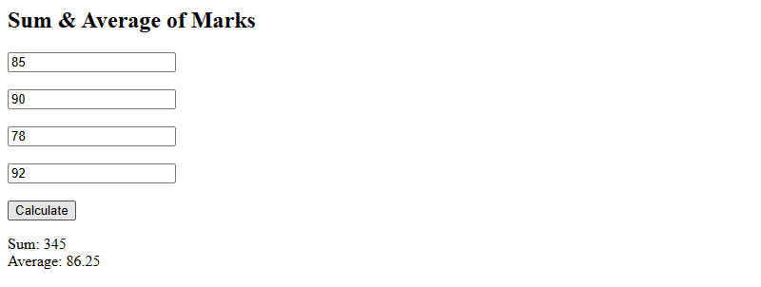

Practical 2 : Write a program to enter a three digit number and find out the sum of all the digits
Source Code:
<html>
<head><title>Practical 2 - Sum of Digits</title></head>
<body>
<h2>Sum of Digits of a Three Digit Number</h2>
<input id="num" type="number" placeholder="Enter 3 digit number">
<button onclick="calc()">Find Sum</button>
<p id="res"></p>
<script>
function calc(){
var n=document.getElementById('num').value;
var sum=0;
for(var i=0;i<n.length;i++) sum+=+n[i];
document.getElementById('res').innerText="Sum of digits: "+sum;
}
</script>
</body>
</html>
Output:
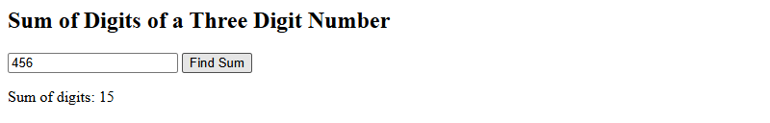

Practical 3 : Write a program to enter the number and find if the number is prime or not
Source Code:
<html>
<head><title>Practical 3 - Prime Check</title></head>
<body>
<h2>Prime Number Check</h2>
<input id="num" type="number" placeholder="Enter a number">
<button onclick="check()">Check</button>
<p id="res"></p>
<script>
function check(){
var n=+document.getElementById('num').value,prime=n>1;
for(var i=2;i<=Math.sqrt(n);i++){if(n%i==0){prime=false;break;}}
document.getElementById('res').innerText=n+(prime?" is Prime":" is Not Prime");
}
</script>
</body>
</html>
Output:
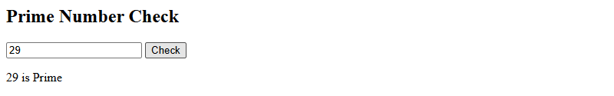

Practical 4 : Write a program to print all the Armstrong numbers from 100 to 500
Source Code:
<html>
<head><title>Practical 4 - Armstrong Numbers</title></head>
<body>
<h2>Armstrong Numbers from 100 to 500</h2>
<button onclick="find()">Find</button>
<p id="res"></p>
<script>
function find(){
var r=[];
for(var i=100;i<=500;i++){
var s=0,t=i.toString();
for(var j=0;j<t.length;j++) s+=Math.pow(+t[j],t.length);
if(s==i) r.push(i);
}
document.getElementById('res').innerText="Armstrong Numbers: "+r.join(", ");
}
</script>
</body>
</html>
Output:
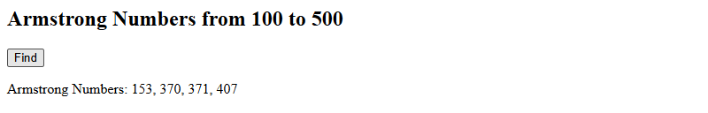

Practical 5 : Write a program to print first 20 prime numbers
Source Code:
<html>
<head><title>Practical 5 - First 20 Primes</title></head>
<body>
<h2>First 20 Prime Numbers</h2>
<button onclick="find()">Find</button>
<p id="res"></p>
<script>
function find(){
var primes=[],n=2;
while(primes.length<20){
var ok=true;
for(var i=2;i<=Math.sqrt(n);i++){if(n%i==0){ok=false;break;}}
if(ok) primes.push(n);
n++;
}
document.getElementById('res').innerText=primes.join(", ");
}
</script>
</body>
</html>
Output:
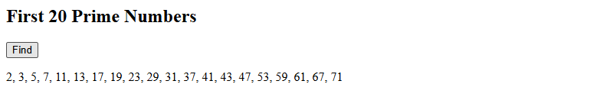

Practical 6 : Write a JavaScript program to demonstrate all the events of the Keyboard and Mouse
Source Code:
<html>
<head><title>Practical 6 - Keyboard & Mouse Events</title>
<style>
#box{width:200px;height:200px;background:#ccc;display:flex;align-items:center;justify-content:center;margin:10px 0;cursor:pointer}
</style>
</head>
<body>
<h2>Keyboard & Mouse Events</h2>
<input id="inp" placeholder="Type here for keyboard events"><br><br>
<div id="box">Hover/Click Me</div>
<p id="log"></p>
<script>
var log=document.getElementById('log');
function show(e){log.innerHTML=e+"<br>"+log.innerHTML;}
var inp=document.getElementById('inp');
inp.onkeydown=function(e){show("keydown: "+e.key);};
inp.onkeyup=function(e){show("keyup: "+e.key);};
inp.onkeypress=function(e){show("keypress: "+e.key);};
var box=document.getElementById('box');
box.onclick=function(){show("click");};
box.ondblclick=function(){show("dblclick");};
box.onmousedown=function(){show("mousedown");};
box.onmouseup=function(){show("mouseup");};
box.onmouseover=function(){show("mouseover");};
box.onmouseout=function(){show("mouseout");};
box.onmousemove=function(e){show("mousemove: "+e.clientX+","+e.clientY);};
box.oncontextmenu=function(e){e.preventDefault();show("contextmenu (right-click)");};
</script>
</body>
</html>

Output:
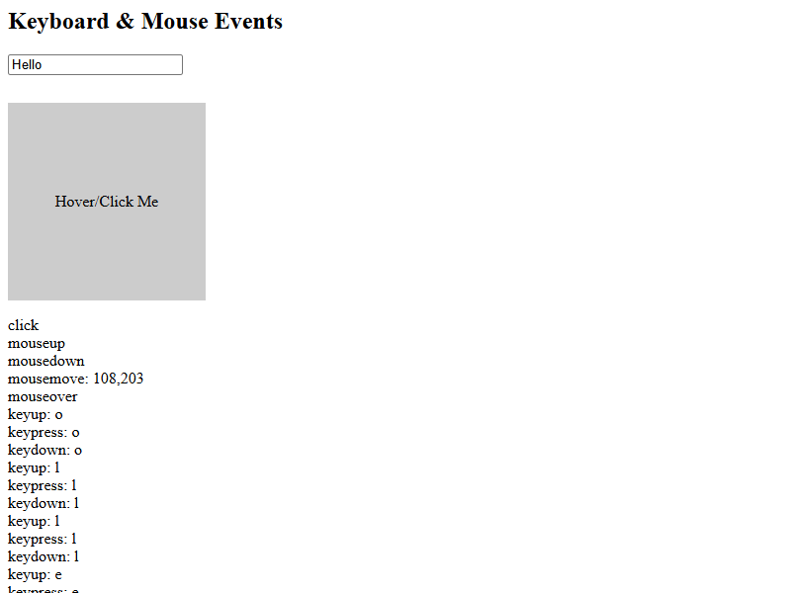

Practical 7 : Write a ReactJS Component to find the largest among three numbers
Source Code:
<html>
<head>
<title>Practical 7 - Largest Among Three (ReactJS)</title>
<script src="https://unpkg.com/react@18/umd/react.development.js"></script>
<script src="https://unpkg.com/react-dom@18/umd/react-dom.development.js"></script>
<script src="https://unpkg.com/@babel/standalone/babel.min.js"></script>
</head>
<body>
<div id="root"></div>
<script type="text/babel">
function App(){
const [a,setA]=React.useState('');
const [b,setB]=React.useState('');
const [c,setC]=React.useState('');
const [res,setRes]=React.useState('');
function find(){
setRes("Largest: "+Math.max(+a,+b,+c));
}return(<div>
<h2>Find Largest Among Three Numbers (ReactJS)</h2>
<input type="number" placeholder="Number 1" value={a} onChange={e=>setA(e.target.value)}/><br/><br/>
<input type="number" placeholder="Number 2" value={b} onChange={e=>setB(e.target.value)}/><br/><br/>
<input type="number" placeholder="Number 3" value={c} onChange={e=>setC(e.target.value)}/><br/><br/>
<button onClick={find}>Find Largest</button>
<p>{res}</p>
</div>
);
}
ReactDOM.createRoot(document.getElementById('root')).render(<App/>);
</script>
</body>
</html>
Output:
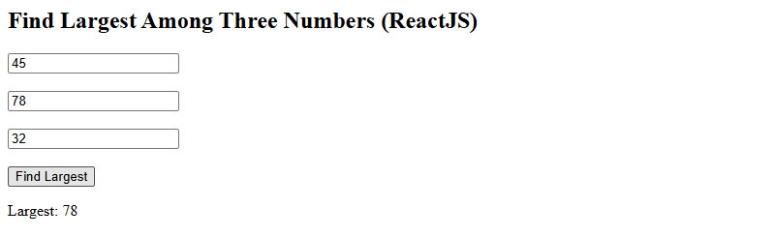

Practical 8 : Write a NodeJS Code to create a server and send the Rno, Name and Marks in 4 subjects from the client form to the server and return the sum of the marks obtained
Source Code (practical8_client.html):
<html>
<head>
<title>Practical 8 - Student Marks Form</title>
</head>
<body>
<h2>Student Marks Form</h2>
<form method="POST" action="/">
<input name="rno" placeholder="Roll No"><br><br>
<input name="name" placeholder="Name"><br><br>
<input name="m1" type="number" placeholder="Subject 1"><br><br>
<input name="m2" type="number" placeholder="Subject 2"><br><br>
<input name="m3" type="number" placeholder="Subject 3"><br><br>
<input name="m4" type="number" placeholder="Subject 4"><br><br>
<button type="submit">Submit</button>
</form>
</body>
</html>
Source Code (practical8_server.js):
const http = require('http');
const qs = require('querystring');
http.createServer((req, res) => {
if (req.method === 'GET') {
res.end(“Server is running”);
} else {
let body = '';
req.on('data', d => body += d);
req.on('end', () => {
const p = qs.parse(body);
const sum = +p.m1 + +p.m2 + +p.m3 + +p.m4;
res.writeHead(200, { 'Content-Type': 'text/html' });
res.end('<html><body><h2>Result</h2><p>Roll No: ' + p.rno + '</p><p>Name: ' + p.name + '</p><p>Marks: ' + p.m1 + ', ' + p.m2 + ', ' + p.m3 + ', ' + p.m4 + '</p><p><b>Sum: ' + sum + '</b></p><a href="/">Back</a></body></html>');
});
}
}).listen(3000, () => console.log('http://localhost:3000'));

Output (Before Submit):

Output (After Submit):
